**YOUR ROCKET!**

Today you are going to be an engineer- a space engineer!

You are going to design your own space rocket.

1. Look at the information about rockets. What is important? Highlight useful words.
2. Plan your rocket.

Highlight special words you want to use.

What do astronauts *need* on a rocket?

What must the space rocket be able to do?

What might astronauts *like* on a rocket?

Astronauts do scientific experiments. Where will they do these?

1. Draw and label your rocket. It is important to give really good information, so remember to label it well with lots of detail!

**SPACE ROCKETS**

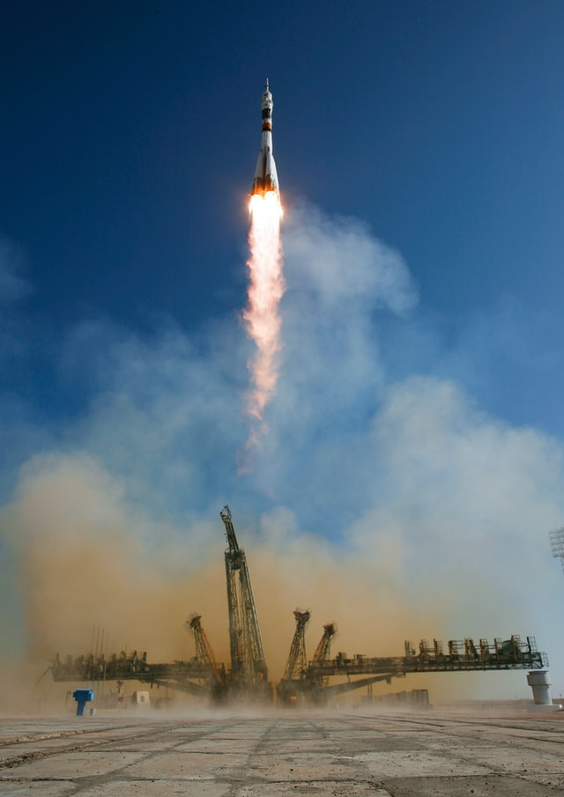

Rockets have rocket boosters to help them take off. The boosters parachute back to Earth once the rocket has taken off.

After a few more minutes, the fuel tank is empty and falls off. It burns up in the Earth’s atmosphere.

The astronauts need to be able to pilot and control the rocket. They also need computers on board and communication equipment.

Of course, rockets need a door or ‘hatch’ so that they astronauts to get in and out!

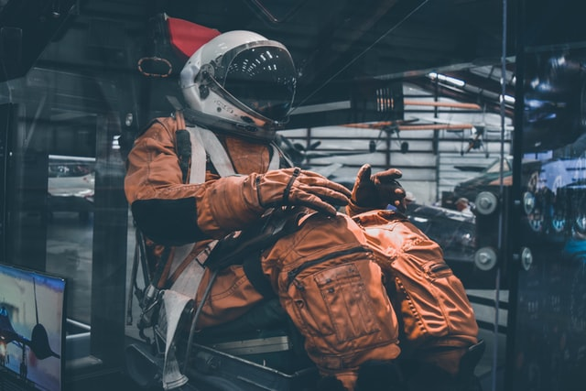

The astronauts have straps on their beds and chairs to stop them floating around and make them comfortable. They also have somewhere to exercise. Plus, they have to take special food with them. It is often dehydrated food which means the water has been taken out and it is very light.

As rockets descend (come down) to Earth, they need parachutes to slow them down.

YOUR ROCKET! – An example of my rocket!

Today you are going to be an engineer!

You are going to design your own space rocket.

1. Look at some information about rockets. What is good? Highlight useful words. Yes, I did this.
2. Plan your rocket. Answer these questions. Highlight special words you want to use.

What do astronauts *need* on a rocket?

They need a place to eat and a toilet!

They need to equipment and computers to pilot the rocket.

What must the space rocket be able to do?

The rocket must be able to blast off into space with boosters and a fuel tank.

It must be able to slow down with parachutes when it descends.

The rocket must be able to withstand high temperatures.

What might astronauts *like* on a rocket?

They might like a comfortable bed.

They might want to communicate with family at home.

Astronauts do experiments. Where will they do these?

I will make a small area with science equipment.

1. Draw and label your rocket.

It is important that engineers and designers give really good information, so remember to label it well with lots of detail!

